WEEK 3 ASSIGNMENT
User Interface (UI) Development
SACCO Mobile Application

Student: Meitaya Verizon
Institution: Mount Kenya University
Programme: BIT/ICT
Tools Used: Figma + Flutter
GitHub: https://github.com/meitayaverizon892-create/sacco-app
Date: June 2026

1. Project Overview
This report documents the development of a SACCO (Savings and Credit Cooperative Organization) Mobile Application UI Prototype as part of the Week 3 Assignment on User Interface Development. The app was designed using Figma for wireframing and GUI design, then converted to a fully functional Flutter application tested on a real Android device.

2. Tools Used
• Figma — Wireframing and GUI Design
• Flutter 3.22.2 — Mobile App Development
• VS Code — Code Editor
• Android Device (Android 13) — Real Device Testing
• GitHub — Version Control and Submission

3. App Screens (5 Screens)
The SACCO App consists of 5 screens as required by the assignment. Each screen was first designed in Figma then implemented in Flutter.

Screen 1: Splash Screen
• Displays SACCO APP logo and tagline 'Saving Together'
• Features fade-in and scale animation
• Loading spinner with automatic navigation to Login after 4 seconds
[ INSERT SPLASH SCREEN SCREENSHOT HERE ]

Screen 2: Login Screen
• Member ID and Password input fields
• Password visibility toggle
• Form validation with red error Snackbar
• Loading animation on LOGIN button
• Slide transiti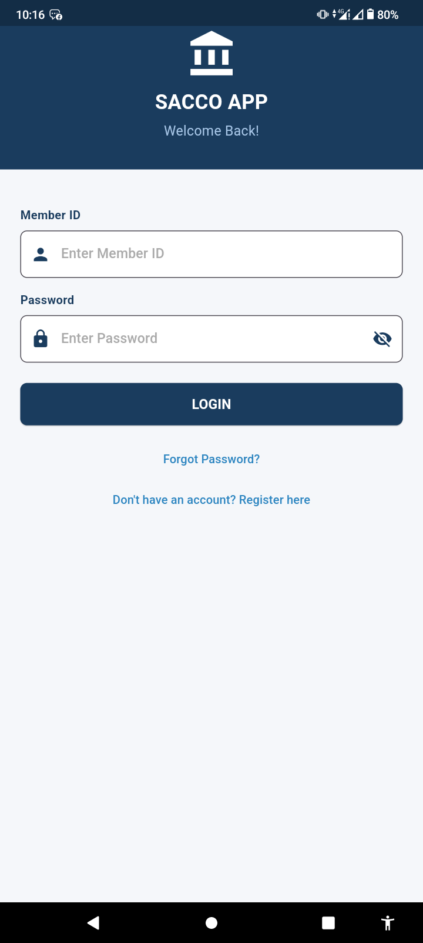on to Dashboard

Screen 3: Dashboard
• Welcome header with member name and notification bell
• Total Savings card showing KSH 45,000
• Quick Stats: Active Loans and My Savings cards
• Quick Actions: Apply for Loan, View Members, My Account buttons
• Recent Activity section

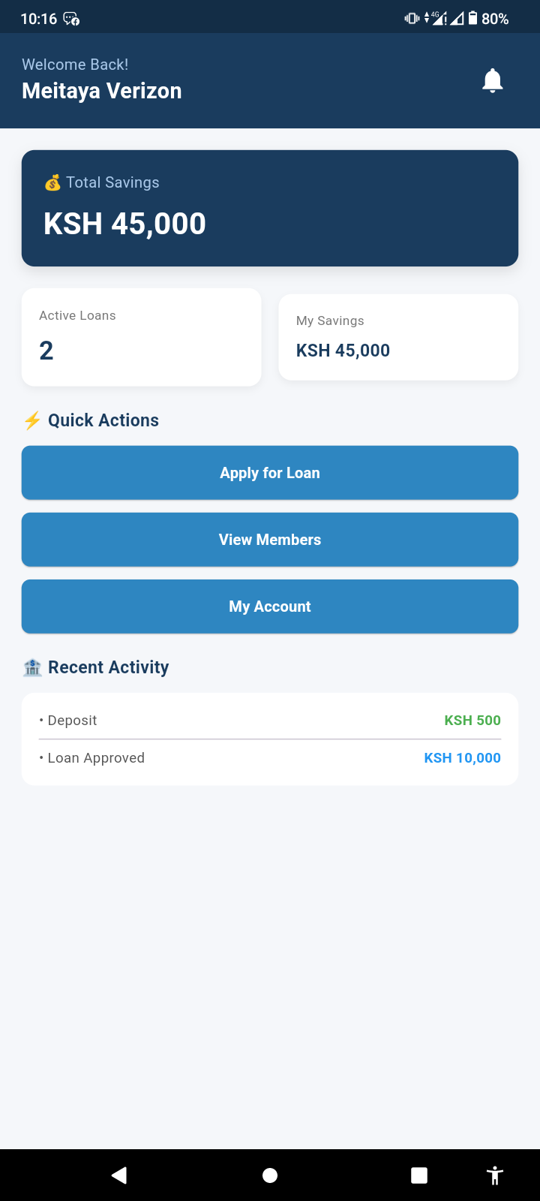

Screen 4: Members List
• Header with back navigation arrow
• Search bar for filtering members
• Scrollable list of 5 SACCO members
• Each card shows member name, ID and savings amount
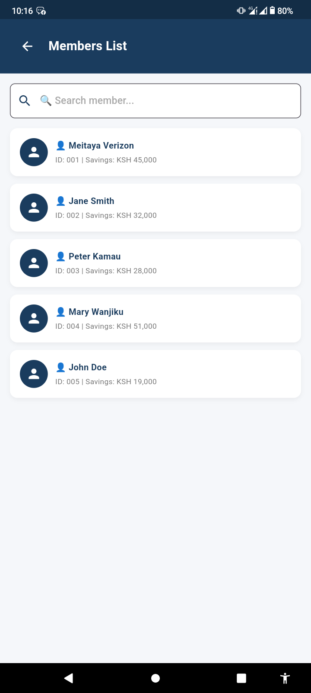

Screen 5: Apply for Loan
• Header with back navigation arrow
• Loan Amount input field
• Loan Purpose input field
• Loan Duration input field
• Guarantor Name input field
• SUBMIT LOAN button with validation
• Green success Snackbar on successful submission
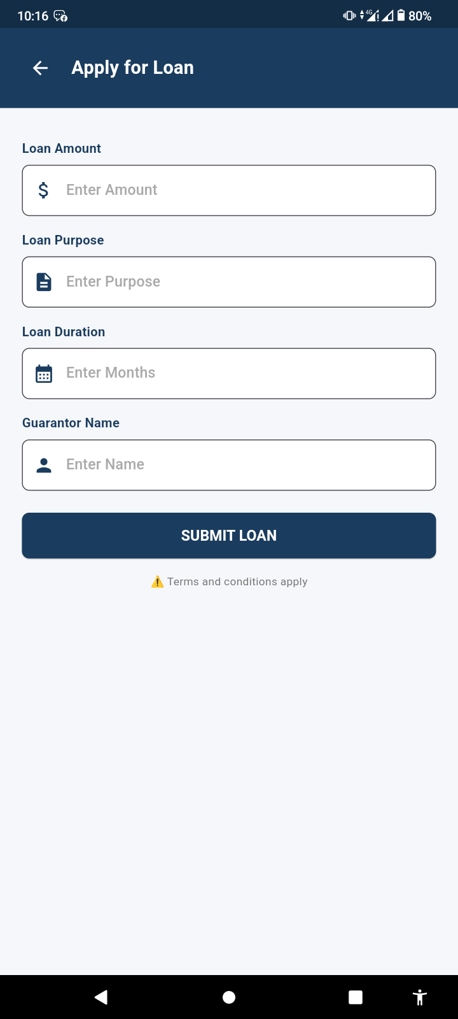

4. Navigation Flow
The app navigation follows this flow:
Splash Screen → Login Screen → Dashboard
Dashboard → Members List → Back to Dashboard
Dashboard → Apply for Loan → Back to Dashboard
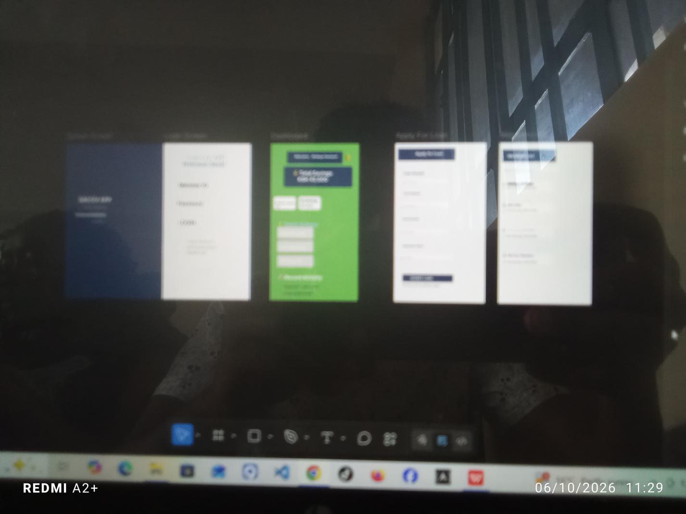

5. UI Features Implemented
✓ Animations — Fade and scale animation on Splash Screen
✓ Transitions — Slide transition from Login to Dashboard
✓ Form Validation — Empty field detection with error alerts
✓ Alerts — Red error and green success Snackbars
✓ Loading Indicator — Spinning circle on Login button
✓ Password Toggle — Show/hide password feature
✓ Responsive Design — Works on all Android screen sizes
✓ Real Device Testing — Tested on Android 13 device

6. Real Device Testing
The app was successfully installed and tested on a real Android device with the following specifications:
• Device: 23028RNCAG
• Android Version: Android 13 (API 33)
• Architecture: android-arm
• All 5 screens loaded and navigated correctly
[ INSERT REAL DEVICE TESTING SCREENSHOT HERE ]

7. GitHub Repository
All project files including Flutter code and Figma design files have been submitted to GitHub:
Repository: https://github.com/meitayaverizon892-create/sacco-app
• lib/screens/ — All 5 Flutter screen files
• lib/main.dart — App entry point
• figma_design/ — Figma design export files
[ INSERT GITHUB REPOSITORY SCREENSHOT HERE ]

8. Conclusion
The Week 3 Assignment has been successfully completed. A fully functional SACCO Mobile Application UI Prototype was built using Figma for design and Flutter for development. The app meets all assignment requirements including 5 screens, working navigation, responsive design, modern UI, and functional forms. The project has been tested on a real Android device and submitted to GitHub.

